EnterBridge Technologies

200 Westgate Pkwy #104,

Richmond,

VA 23233

(804) 290-0546

PROCESS DEFINITION DOCUMENT

New Interviewees

Sales Opportunity Conversion

## DOCUMENT VERSION HISTORY

|  |  |  |
| --- | --- | --- |
| **Version** | **Author** | **Date** |
| 1.0 | James Gebler | 7/29/2021 |

## 

## SIGNED OFF BY

|  |  |  |
| --- | --- | --- |
| **Name** | **Function** | **Responsibility** |
|  |  |  |
|  |  |  |

## 

## CONTRIBUTORS

|  |  |  |
| --- | --- | --- |
| **Name** | **Function** | **Responsibility** |
|  |  |  |
|  |  |  |

# 

# Current process analysis

## High level description

The process is used to daily download a sales opportunity report and convert the total price of each row into USD, if not already in USD.

The employee every day:

1. Opens https://www.rpasamples.com/opportunities
2. Downloads the Details-only spreadsheet in .xlsx format
3. Saves the file to a Sales folder
4. Gets the current conversion rate to USD from EUR, JPY, and INR
5. Writes these values into a table on a different sheet as a reference
6. Using the Vlookup formula and depending on the currency, multiplies the Total Price column for each row by the current conversion rate in the new sheet, and writes the value into a new column, “Sales in USD.”

## Systems involved

|  |  |  |
| --- | --- | --- |
| **System** | **Used for** | **User role needed** |
| **https://www.rpasamples.com/opportunities** | Exporting the data | N/A |
| **Excel** | Manipulating and writing data | N/A |

## 

## Process flow

Here is a description of the process in the form of a flow chart:

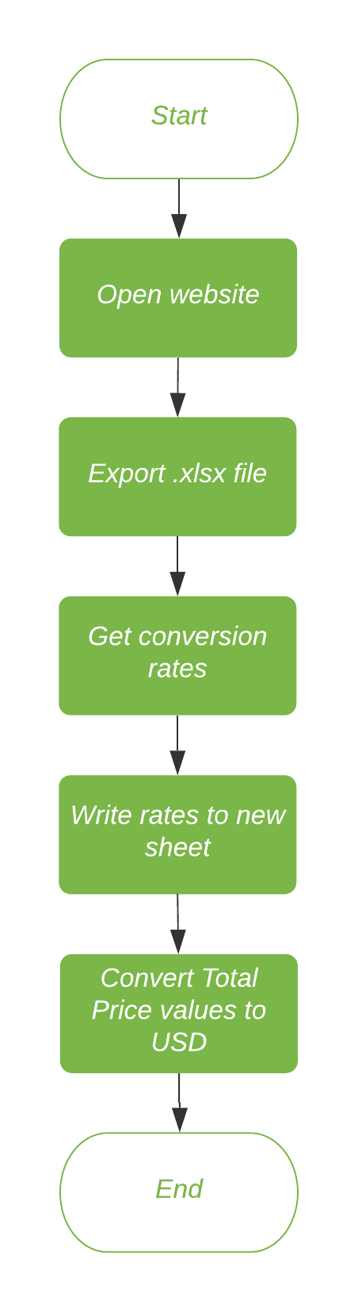

## Detailed steps

### Open https://www.rpasamples.com/opportunities

The employee navigates to https://www.rpasamples.com/opportunities.

### Export and save .xlsx file

The employee clicks Export > Details Only > Excel (*.xlsx) > Export and then saves the file to Documents > Sales > “New Opportunities (USD)” (the folder is created if it does not already exist).

### Get conversion rates

For each currency, the employee googles “[currency] conversion rate” and gets the number.

### Write rates to new sheet

The employee creates a new worksheet entitled “Conversion Rates,” and in that worksheet the employee creates a new table with the column headers “Currency” and “Conversion Rate”. The table should have 4 rows, excluding the headers. For each currency, the employee writes the conversion rate into the table in the Conversion Rates worksheet.

### Convert Total Price values to USD

The employee creates a new column entitled “Total Sales USD” in the “Opportunities” worksheet. In each cell (starting in H2), the employee uses the following Vlookup formula to look into the Conversion Rates spreadsheet and retrieve the rate and then multiply it by the total price: =VLOOKUP($I2,ConversionRates!$A$2:$B$5,2,FALSE)*G2

This is copied down the entire column. The employee then saves the file.

## Possible exceptions

### Logic Exceptions

#### Unidentified Currency

The employee comes across a currency that wasn’t listed in the PDD. The employee should add that currency rate to the table in ConversionRates worksheet and expand the vlookup formula to include the additional row.